Tab 1



Mtel (Thailand) Co., Ltd.

For

T.C.C. Technology Co., Ltd.

One Bangkok Mobile Application
Migration Campaign
User Manual Document
To
T.C.C. Technology Co., Ltd.

Total 8 sheets (w/h cover sheet)
 | PROJECT NAME | JOB NO. | DOCUMENT NO. | REV.
 | One Bangkok Mobile Application - Migration Campaign User Manual Document |  |  | 01

Content table
1. Document Purpose 3
2. Feature Overview 4
3. Migration Campaign 4
3.1. Purpose 4
3.2. User Perspective – What the User Experiences 4
3.3. Operational Process – How the Campaign Works 7
3.4. Eligibility Conditions 7
3.5. Error Handling & Known Scenarios 8

One Bangkok Mobile Application - Invitation Code and Upgrade Membership
To
T.C.C. Technology Co., Ltd.
This document serves as the official User Manual for the Migration Campaign feature within the One Bangkok Application. The purpose of this manual is to provide clear guidance on how this feature operates following its implementation as part of the One Bangkok user migration initiative.
The Migration Campaign is a fully automated backend process triggered upon a user's first login or account merge via the One Bangkok Application. Upon successful account creation or merge, the system automatically checks campaign eligibility and, if conditions are met, redeems the campaign on behalf of the user — requiring no action from the user at any point.
This manual outlines the feature objective, user experience, operational process, eligibility rules, system behaviors, and error scenarios to support Customer Support and Operations Teams at T.C.C. Technology Co., Ltd. in effectively monitoring and managing this feature.

Document Purpose
This User Manual provides operational guidance for the Migration Campaign feature within the One Bangkok Application.
The document explains:
- Feature overview and objective
- What the user experiences during the flow
- How the automated backend process works end-to-end
- Eligibility conditions and business rules
- System error scenarios and handling
- Environment configuration reference for operations
This manual is intended for:
- Customer Support Team
- Operations Team
It complements the approved Statement of Work (SOW) and Technical Design Document (TDD).

Feature Overview
The Migration Campaign feature provides an automated campaign benefit to eligible users upon their first login or account merge via the One Bangkok Application.
The feature is integrated with the following systems, which work together to deliver the campaign benefit seamlessly:
- SSO — orchestrates the eligibility check and redemption flow upon account creation or merge
- BZB — provides campaign details, server authentication, and processes the campaign redemption
- Connect X — receives a CRM update reflecting the user's redemption status and marketing preference
The feature is controlled by an environment-level feature flag. When enabled, the campaign flow runs automatically every time a user completes their first login or account merge. No user action is required at any step.

Migration Campaign

Purpose
The Migration Campaign allows the business to reward eligible users who migrate to the One Bangkok Application by automatically redeeming a pre-configured campaign on their behalf upon first login or account merge.
The campaign benefit is delivered silently in the background — the user simply logs in or merges their account and the system handles the rest.

User Perspective – What the User Experiences
From the user's point of view, the Migration Campaign is completely invisible. There is no additional screen, prompt, or action required.

The user experience is as follows:
Step 1 –First Login or Account Merge: The user completes their first login or account merge via the One Bangkok Application as normal. No additional screen or prompt is shown related to the campaign. (Also allows for Manual Merge)

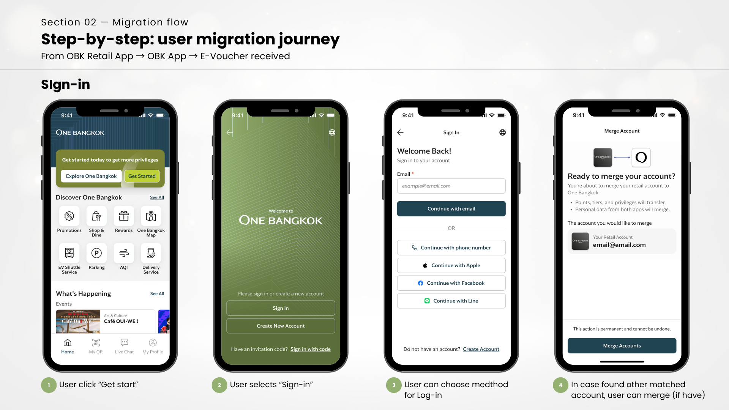

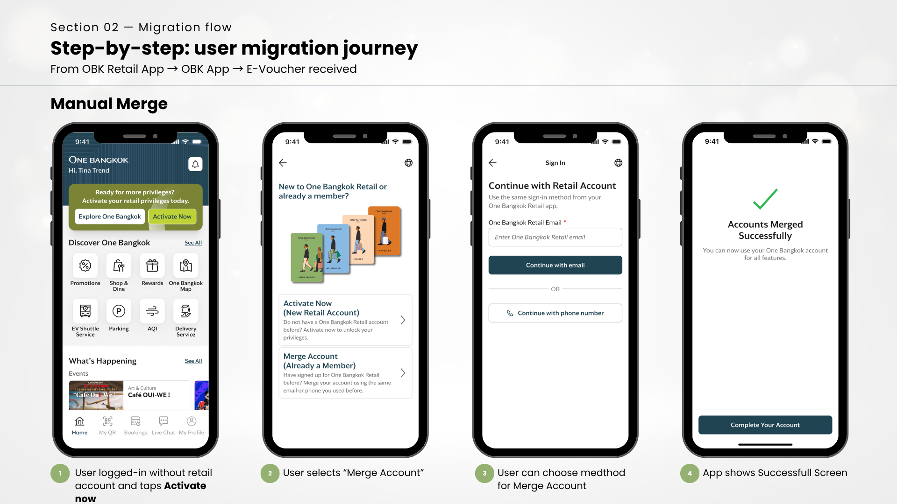

Step 2 – Automatic Campaign Processing Immediately after the account is successfully logged-in or merged, the system automatically checks campaign eligibility and processes the redemption in the background. The user is notified by notification.

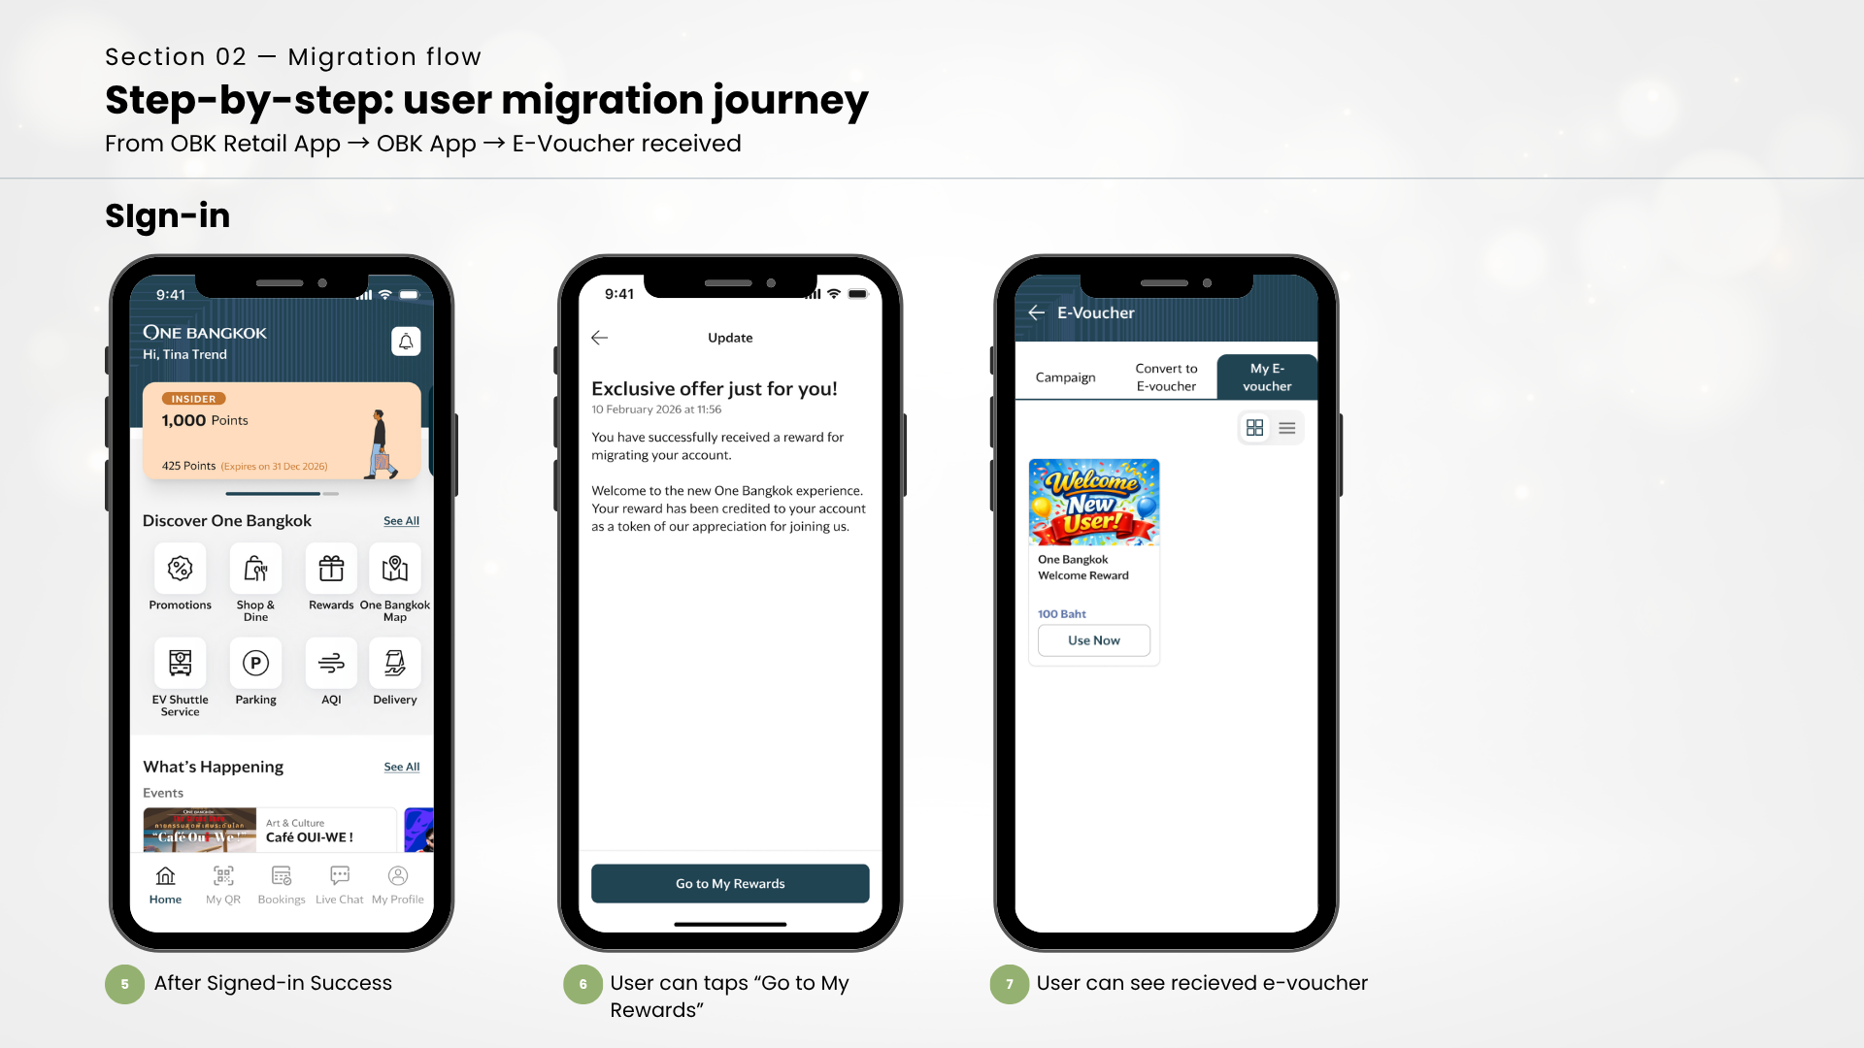
Step 3 – Campaign Benefit Delivered If the user is eligible, the campaign is redeemed on their behalf. The benefit is reflected in their account according to the campaign configuration in BZB. The user may see the benefit reflected in their rewards or profile depending on the campaign type
- Note for Customer Support: If a user contacts support asking about a campaign benefit they expected to receive upon first login, refer to Section 3.4 (Eligibility Conditions) and Section 3.5 (Error Handling) to assess whether the campaign was processed successfully.

Operational Process – How the Campaign Works
The following describes the end-to-end automated flow that runs in the background each time a user completes first login or account merge.
1. Trigger The flow is triggered automatically by SSO upon successful account creation or account merge via the One Bangkok Application.
2. Feature Flag Check The system checks whether the feature flag CHECK_AND_REDEEM_CAMPAIGN_IF_ELIGIBLE is set to true and whether a valid CAMPAIGN_ID is configured in the environment.
- If either condition is not met → the flow stops immediately. No campaign action is taken.
3. Campaign Eligibility Check The system calls BZB to retrieve campaign details using the configured CAMPAIGN_ID. The following conditions are evaluated:
- Campaign has remaining quota (qty > 0)
- Campaign has not expired (now < ExpireDate)
- User registered before the campaign start date (register_date < StartDate)
- If
  - All three conditions are met → the user is eligible and the flow continues.
  - Any condition is not met → the flow stops. No redemption is attempted.
4. BZB Server Authentication The system authenticates server-side with BZB using the user's BKL ID to obtain a server token (JWT). This token is used to authorize the redemption call on behalf of the user.
5. Campaign Redemption The system calls the BZB redemption API using the server token.
- If redemption is successful, the system confirms that isRedeemed = true and that the accountId and campaignCode are present in the response.

Eligibility Conditions
All three conditions below must be true for a user to receive the campaign benefit. If any condition fails, the campaign will not be redeemed and no error is shown to the user.
Condition | Rule | Description
Campaign quota | qty > 0 | The campaign must still have available redemptions remaining
Campaign validit | now < ExpireDate | The current date must be before the campaign expiry date
User registration timing | register_date < StartDate | The user must have registered before the campaign start date
- Note for Operations: If users are reporting missing campaign benefits, the first check should be whether the campaign quota has been exhausted (qty = 0) or the campaign has expired. Both will silently prevent redemption without any error to the user.

Error Handling & Known Scenarios
The following table describes known error scenarios, their causes, and the recommended action for Customer Support and Operations teams.
BZB Campaign Check Errors
Scenario | Cause | User Impact | Action
Campaign quota exhausted | qty = 0 at time of user's first login | Campaign not redeemed. No error shown to user | Check campaign quota in BZB. If campaign should still be active, contact BZB/Retail BU to review quota configuration
Campaign expired | Current date is past ExpireDate | Campaign not redeemed. No error shown to user | Confirm with Retail BU whether the campaign period should be extended
User registered after campaign start date | register_date >= StartDate | User is not eligible by design | This is expected behavior. No action required
Session expired (409) | BZB session invalid during campaign check | Campaign not redeemed | Investigate SSO–BZB session handling. Escalate to technical team if recurring
BZB Redemption Errors
Scenario | Cause | User Impact | Action
Redeem limit reached (409) | User has already redeemed this campaign | Campaign not redeemed again | Expected behavior for returning users. No action required
BZB redemption failure | BZB service error during redemption | Campaign not redeemed | Escalate to technical team to review BZB integration logs
Feature Flag / Configuration Errors

Scenario | Cause | User Impact | Action
Feature flag disabled | CHECK_AND_REDEEM_CAMPAIGN_IF_ELIGIBLE = false | Campaign flow does not run | Confirm with Operations whether the flag should be enabled. Do not change environment config without authorization
Campaign ID not configured | CAMPAIGN_ID missing from environment | Campaign flow does not run | Confirm correct Campaign ID with Retail BU and escalate to technical team to update environment configuration

